ENPM 661 – Planning for Autonomous Robots

Project 2

Abhinav Modi

116346849

Problem Statement

Implementing A-star and Dijkstra algorithms for a point robot and a rigid robot on a given map.

**Directory Structure**

The zip file contains:

* README.docx
* Planning.py

Running the Code

The .zip file consists of a python code “Planning.py” which consists the pipeline for running the two algorithms. Extract the zip file and open terminal in that directory. Run the following command for execution for dijkstra

$ python Planning.py --mode=dijk

and for A-star:

$ python Planning.py --mode=astar

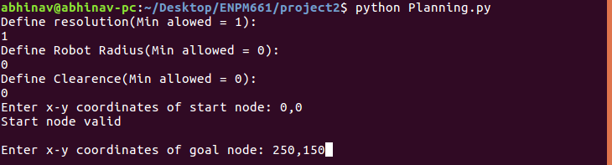

**For Point robot:**

To run the code for point robot keep the Robot Radius as 0.

**Changing Resolution(Scale) of the Grid**

The minimum resolution allowed for the grid is 1 which corresponds to the maximum number of nodes possible(250 along x direction times 150 along the y direction). As the resolution is increased, the scale of the grid will increase i.e., resolution of 2 will generate a grid with 125 points along x-direction times 75 along the y-direction.

**Start and Goal Node limits**

The grid ranges from (0,0) to (250,150) with obstacles as given in the problem statement.

**Result**

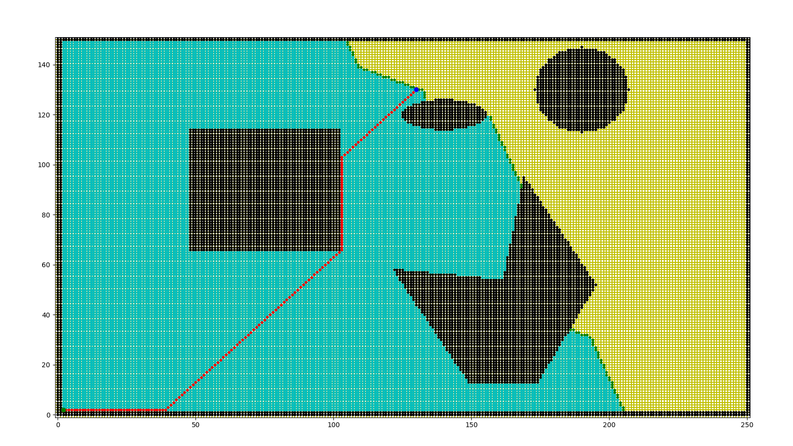 Here is shown the output of a sample situation with the following parameters:

Resolution: 1

Robot Radius: 0

Clearance: 2

Start Node: 0,0

Goal Node: 130,130

The blue nodes are explored nodes, green are the active/open nodes and Red is the optiimal path obtained using dijkstra